JPEG Double Compression By Channel Splitting
T Apoorva Singh
Department of ICE, Amity School of Engineering & Technology, GGSIP University
Address
Apoorv-singh@outlook.com

Abstract— This paper aims to shed light on the double compression for a JPEG image, where an input image undergoes compression two times with a different threshold value each time to achieve compression. The compression begins by, converting the image data into frequency domain and then removing finer details from the image using a threshold value for size reduction. The presented method splits the input image into Red, Green, Blue channels and then processes them to achieve compression. The resulting image is of a considerably smaller size in comparison to the original, without much loss in the image quality and with a mean square error and a low signal to noise ratio. Thus, compression can make for efficient storage, faster transmission times and low bandwidth consumption.

Keywords— JPEG; Compression; DCT; Image Processing;
- Introduction
The main aim of image compression is to reduce the size and the data redundancy of a given image for efficient storage or transmission.
JPEG (Joint Photographics Experts Group) is one of the most popular types of image formats because it’s able to achieve high compression ratios with little loss in quality [1]. Use of algorithms such as DCT, have become the de facto standard for image compression.
In this paper we explore methods to compress an image with by applying DCT to each individual channel in the image and them compressing them.
- Methods
An image is basically a matrix made up of large amount of pixel data values which for an 8 bit image, range from 0 to 255(pure black to pure white) [3]. The number of bits required to form an image can be minimized by removing the redundancies present in the image.
- Types of Redundancies
1. Spatial Redundancy, is due to the similarity which neighboring pixel have, where they either have same or highly correlated values.
2. Spectral Redundancy, is due to correlation between different color planes or spectral bands.
3. Temporal Redundancy, which is present in an image because of correlation between different frames in images.
- Types of Compression
There are basically two type of compression techniques, lossless and lossy compression.
- Lossless compression, allows the original image to be completely reconstructed from the compressed image, without any loss of information. It is usually done by using encoding. Used in legal, medical documents.
- Lossy compression, discards some information to reduce the image size thus allowing for high compression. Final compressed image is only an approximation of the original image. Used for natural images, photographs.

- Discrete Cosine Transform
Human eye is insensitive to high spatial frequencies. DCT compression takes advantage of this by compressing high frequencies more coarsely.
Discrete Cosine Transform [4] is used to convert image data from the spatial domain to the frequency domain so that the image’s information exists in a quantitative form that can be manipulated for compression.
The signal of an image can be thought of as a three-dimensional signal. The X and Y-axes of the image’s signal are the two dimensions of the screen, while the amplitude of the signal, the Z-axis, is the value of the pixel at (X, Y). This can be represented visually by a two-dimensional array where each cell contains the numerical value of the pixel at that location.
We use the threshold value for truncating the DCT coefficients [2] in the image matrix to achieve compression. The threshold value can be in the range of 0-255, but we only use values less than 30, because the quality loss will be quite noticeable after that. Even very low values can achieve huge size reduction of image.
The 2D-DCT of an N by N image can be calculated by using the formula:
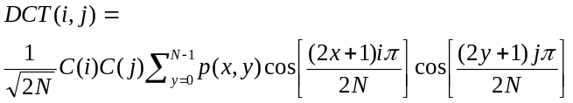
- Procedure
The double compression of image is done by implementing the following steps [2]:
- Read an input image.
- Compute its dimensions and file size.
- Select a threshold value.
- Make the image of equal dimensions (square image).
- Apply DCT to each pixel block in image matrix.
- Split image into RGB channels and find DCT coefficients for each channel.
- Truncate the DCT coefficients less than the threshold value in each channel to achieve compression.
- Combine the three channels back to form the compressed image.
- Repeat steps after step two to achieve double compression.
- Calculate PSNR, MSE and CR, then output the results and save the images.
- Measurement Factors
Other measurement factors [5] for an image are:
- MSE (Mean Square Error), it is the averages of the squares of the errors. It is always non negative and values closer to zero are good.
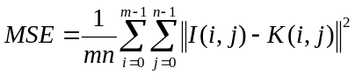
- PSNR (Peak Signal to Noise Ratio), It is the ratio between the maximum possible power of a signal and the power of corrupting noise. For 8bit images the acceptable range is 30 to 60 Db.
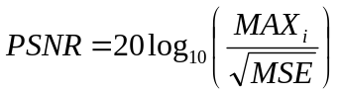
- CR (Compression Ratio), It is the ratio between the information carrying bits in the original image (n1) to the reconstructed image (n2).
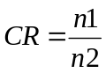
- Experiment Results
The improved results are obtained for the double compression of the JPEG images by using different threshold values.
Thus, the results obtained for PSNR are in a range of 30 to 50 db. When we double compress the image we can see that the peak signal to noise ratio gets higher, while the mean square error gets reduced.
Having a higher PSNR value and low MSE value is the optimum for any image, as higher PSNR generally equates to better quality.
By using these different threshold values there is reduction in the file size with an almost negligible degradation in the quality of the image with huge improvements in the compression ratio, mean square error and peak signal to noise ratio.
Results for Image 1:

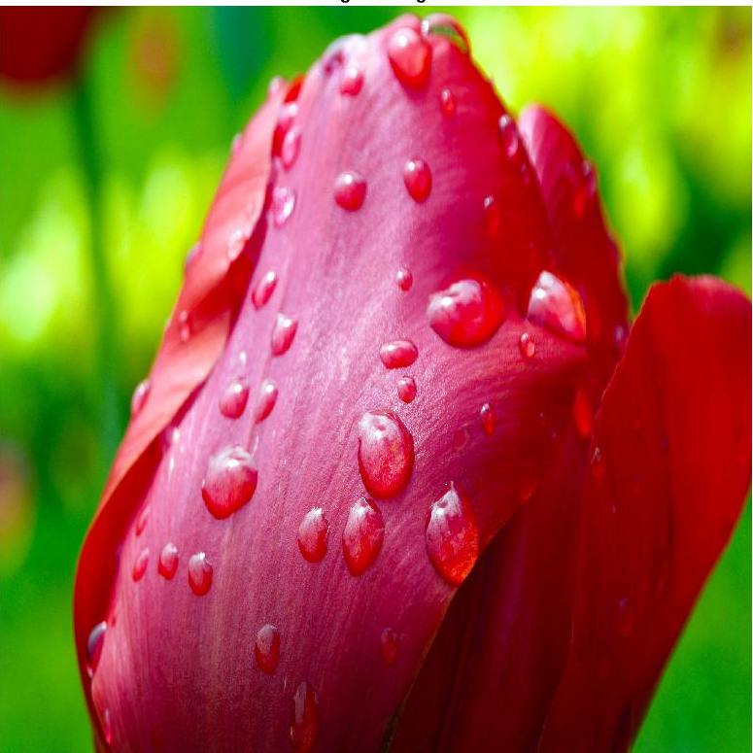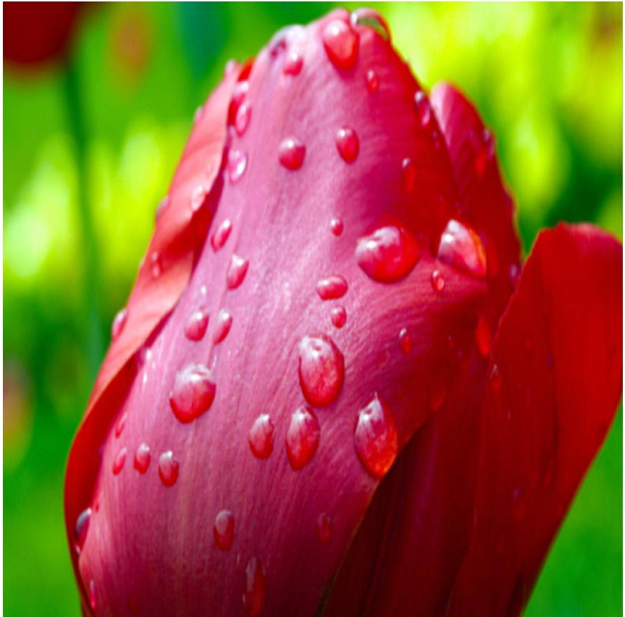
(a) Original Image (b) Double Compressed Image
Fig. 1
Table 1: Results for Image 1
Measurement Factors | Original | Single Compressed | Double Compressed
Size(kb) | 2337.8 | 341.874 | 312.078
Threshold Value | - | 10 | 15
CR | - | 6 | 7
MSE | - | 7.0399 | 1.3488
PSNR | - | 39.655 | 46.831

Result for Image 2:

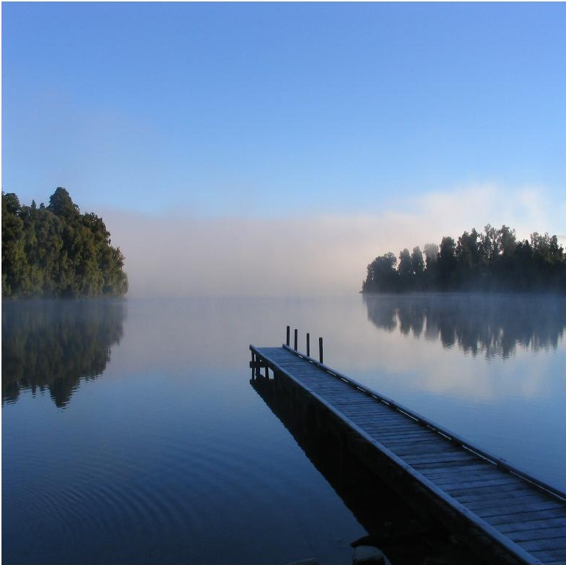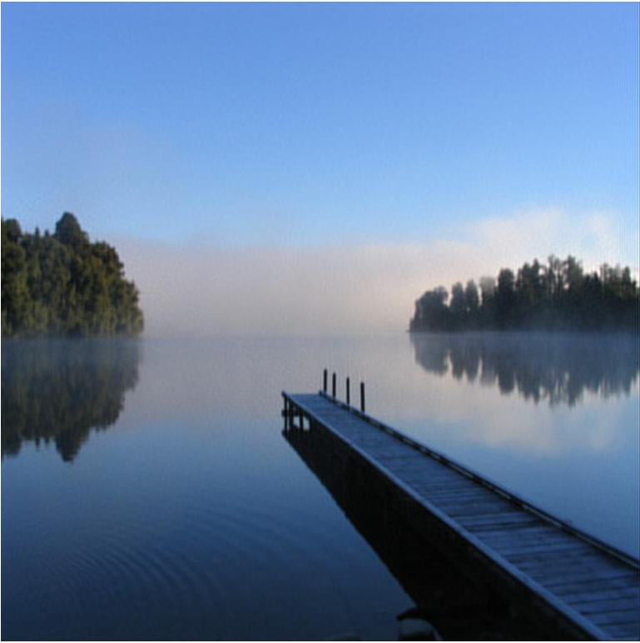
(a) Original Image (b) Double Compressed Image
Fig. 2
Table 2: Results for Image 2
Measurement Factors | Original | Single Compressed | Double Compressed
Size(kb) | 527.26 | 111.219 | 101.126
Threshold Value | - | 10 | 5
CR | - | 5 | 5
MSE | - | 5.714 | 0.2648
PSNR | - | 40.561 | 53.901

Thus we can say that even with very low threshold values we can achieve maximum reduction for image file size.
- Conclusions
Thus, we can say that by compressing the image twice with the suitable threshold values, the size of the image is drastically reduced with remarkable results obtained for CR, MSE and PSNR values. Double compression is especially beneficial for the improved PSNR value of the image. Even with very low threshold values the compression achieved is phenomenal and upon increasing the compression percentage the loss of information stagnates after a certain value.
The method of splitting a RGB image into its specific channels is very efficient as applying DCT to each and every block of the matrix. This method achieves very high compression, without any significant loss in quality. Thus, providing exceptional results.
References
- Gregory K. Wallace., “THE JPEG STILL PICTURE COMPRESSION STANDARD”, IEEE Transactions on Consumer Electronics, Vol. 38, No. 1, FEBRUARY 1992.
- Ankit Chouhan, M.l Nigam., “Double Compression of JPEG Image using DCT with Estimated Quality Factor,” 1st IEEE International Conference on Power Electronics, Intelligent Control and Energy Systems (ICPEICES-2016)
- (2017) JPEG, From Wikipedia. [Online]. Available: https://en.wikipedia.org/wiki/JPEG
- (2017) Discrete Cosine Transform. [Online]. Available: https://en.wikipedia.org/wiki/Discrete_cosine_transform
- A L. Jain. "Fundamentals of Digital Image Processing". PrenticeHaIl, 1989.

